WATER SCARCITY… THE SOLUTION?

Water scarcity has become a worldwide problem and many countries struggle to find water, including Malta. In Malta, 68% of water comes from groundwater, while the rest comes from seawater-desalination and this is costing four times more than underground water.

In this island there are more than 8000 private boreholes and the majority were illegally drilled. It is estimated that about 21,000 liters of water are extracted per minute from these boreholes.

In 2011, the government closed all household boreholes and is installing meters on agricultural and commercial boreholes. All this is being done with a grant of €2 million by the EU. Once installed the ministry responsible will monitor water extraction for one year and afterwards water quotas will be established for farmers.

Is this the solution? Well, let’s hope it is, because as Benjamin Franklin once said “When the well is dry, we learn the worth of water!” 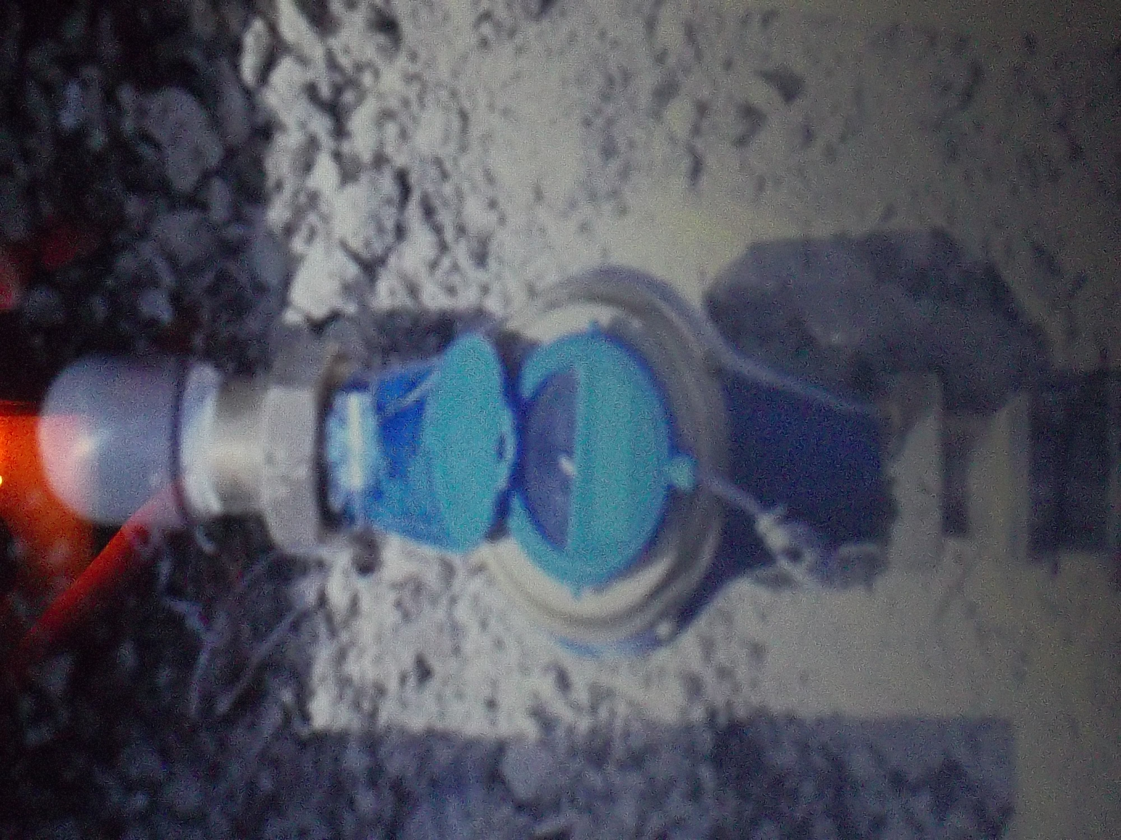

Information: Al Jazeera.com
Water.thinkaboutit.eu
Times of Malta

This photo is being shown with the kind permission of the Ministry for Resources and Rural Affairs.

